Screen Form Design

**Form Mockup:**

**Using Draw.io (see Tutorial for Draw.io)**

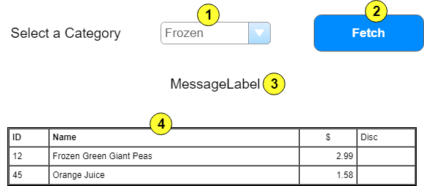

|  |  |  |  |  |  |
| --- | --- | --- | --- | --- | --- |
|  | **Control Name** | **Load/Pos** | **CRUD** | **Validation** | **Event Actions / Notes** |
| 1 | CategoryList |  | R |  | * Page_Load (!IsPostback) * Load ddl for query use * Put load in separate method * Sort on Category Description * List<Category> Category_List() |
| 2 | Fetch | 4 | R |  | * Validate selection made * BLL method * List<Product> Products_FindByCategory(int) * Return data to load GridView |
| 3 | MessageLabel | 4 |  |  | * Used for form messages |
| 4 | ProductList | 2 | R |  | * Filled by products from Fetch query * Customize GridView |
| 5 | Discontinued | 2 | R |  | * Fill by record display on GridLine |